(a)Session Scope Bean
1. C:\apache-tomcat-7.0.42\webapps\ROOT\WEB-INF\classes Counter.java
package beans;
public class Counter
{
private int counter = 0;
public void setCounter(int value)
{
this.counter = value;
}
public int getCounter()
{
return this.counter;
}
public Counter()
{
}
}
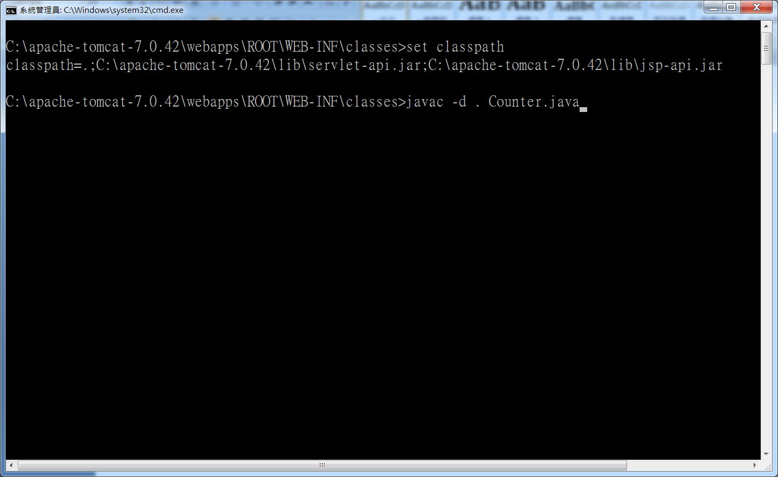
2. C:\apache-tomcat-7.0.42\webapps\ROOT SessionBean.jsp
<HTML>
<HEAD>
<TITLE>Using Beans and Session Scope</TITLE>
</HEAD>
<BODY>
<H1>Using Beans and Session Scope</H1>
<jsp:useBean id="bean1" class="beans.Counter" scope="session" />
<%
bean1.setCounter(bean1.getCounter() + 1);
%>
The counter value is: <jsp:getProperty name="bean1" property="counter" />
</BODY>
</HTML>

(b)Application Object
<HTML>
<HEAD>
<TITLE>Using the Application Object</TITLE>
</HEAD>
<BODY>
<H1>Using the Application Object</H1>
<%
Integer counter = (Integer)session.getAttribute("counter");
String heading = null;
if (counter == null) {
counter = new Integer(1);
} else {
counter = new Integer(counter.intValue() + 1);
}
session.setAttribute("counter", counter);
Integer i = (Integer)application.getAttribute("i");
if (i == null) {
i = new Integer(1);
} else {
i = new Integer(i.intValue() + 1);
}
application.setAttribute("i", i);
%>
You have visited this page <%=counter%> times.
<BR>
This page has been visited by all users <%=i%> times.
</BODY>
</HTML>

Example 3:

<HTML>
<HEAD>
<TITLE>Using the Application Object</TITLE>
</HEAD>

<BODY>
<H1>Using the Application Object</H1>
<jsp:useBean id="bean1" class="beans.Counter" scope="session" />
<jsp:useBean id="bean2" class="beans.Counter" scope="application" />
<%
bean1.setCounter(bean1.getCounter() + 1);
bean2.setCounter(bean2.getCounter() + 1);
%>

You have visited this page The counter value is: <jsp:getProperty name="bean1" property="counter" /> times.
<BR>
This page has been visited by all users The counter value is: <jsp:getProperty name="bean2" property="counter" /> times.
</BODY>
</HTML>

